

FATİH DOĞAÇ
1901042654
CSE312 HW#2 REPORT
Part 1:

SUPERBLOCK  99 byte | FAT  8192 byte | ROOT DIRECTORY  90 byte | DATA BLOCKS  4185923 byte

FILE SYSTEM
4 MB FOR 1 KB BLOCK SIZE
2 MB FOR 0.5 KB BLOCK SIZE
BLOCK COUNT IS ALWAYS 4096

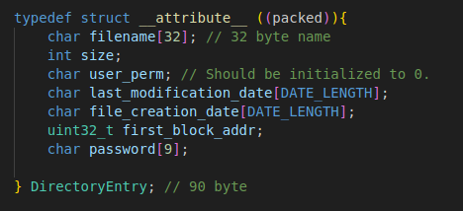

Directory Entries and Directory Table:
Here is the Directory Entry struct. It has 32 bytes for file/directory names. 4 byte for size value. 20 bytes for last modification date and 20 for creation date. 32 bit (4 byte) for the first address block it points. And 8 bytes for password. Total 90 bytes.

I don’t have a directory table. In File Allocation Table (FAT), It holds the index of the next block of this file in the file system’s data blocks part. In this block it has the directory entry of the file. File’s data starts with first_block_addr and can be gathered by continuing on FAT.

Free Blocks:
When initializing the file system, I put -2 in every byte which is 2’s complement representation is 254. That indicates it is empty.
When a block is used, say we have 1 KB block size and we created a file with size of 0.5 KB. Remaining 0.5 KB of the block is still empty. But the block is now considered not empty. If we want to create a new file, we have to start from another block.

File Names:
Every file has 32 bytes for their names.

Permissions:
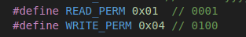

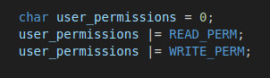

I give permissions like this. And for checking the permission;
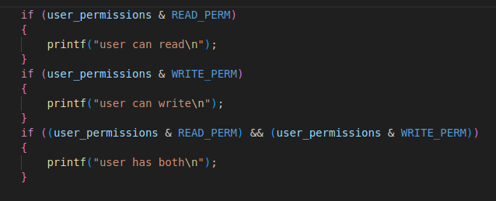

I use the AND operator. If file doesn’t have the permission it can’t go into the if statement.

Password Protection:
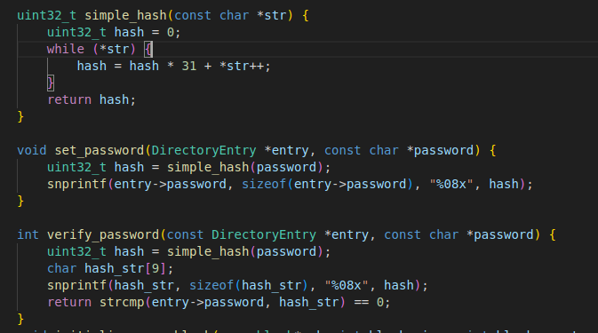

For protection purposes, I add the ascii equivalent of the char and multiply it by 31. set_password hashes the password and verify password is checking if the hashed password is equal to the password.
Superblock:
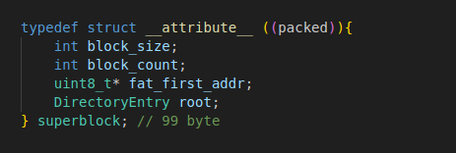

Superblock keeps the information of block size (4 byte), block count ( 4096 as default and 4 byte space), fat table’s start address in file system (1 byte), Directory Entry of the root because someone has to keep it somewhere (90 byte). Total of 99 byte.

